The Center for Wooden Boats

Facility Rental Information Packet

Please read through this packet thoroughly to determine if CWB is the right fit for your event prior to contacting CWB for a rental request.
The Center for Wooden Boats (CWB) is a non-profit maritime museum that selectively agrees to rent a few specific spaces to the public for private functions. Make your event a memorable one surrounded by dockside views of Lake Union while taking in the maritime history and heritage of Seattle!
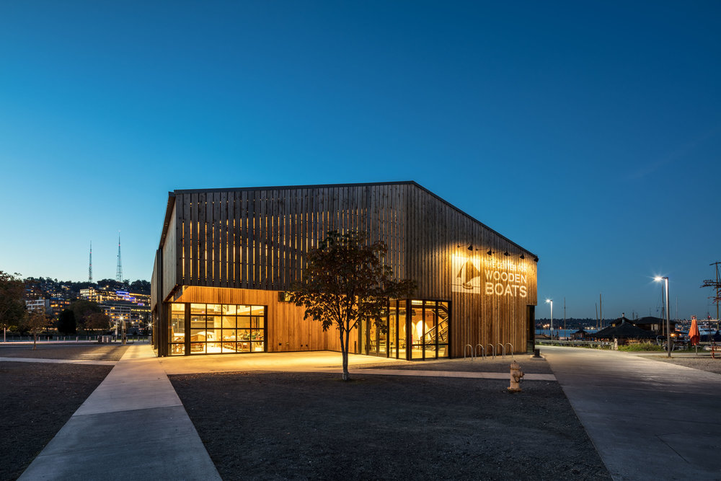

Wagner Education Center- Sail Loft 2
Equipment Included in Rental 3
Floor Plan 4
Boat House 5
Capacity 6
Equipment Included in Rental 6
Additional Equipment & Services 7
Floor Plan 7
General Information 7
Livery Boat Use 8
Boat Moorage 8
Catering & Food Service 8
Deliveries & Pick-Up 8
Set-Up & Clean-Up 8
Concurrent Events in Lake Union Park 9
General Availability 9
Deposit & Payment Policies 9
Deposit Policy 10
Deposit Refund 10
Cancellations 10
Potential Fees 10
Availability & Pricing 12
Rental Timeline 12
Discounts 12
Facility Use 12
Use of Property 12
Open Flame Use 13
Use of CWB’s Grill 13
Parking 13
ADA Access & Parking 14
Loading In 14
Smoking 15
Alcohol 15
Decorations 15
Canopies and Furniture 16
Damage or Defacement of Property 16
Noise Levels 16
Violation of Rules 17
Indemnification 17
Notes 17

Wagner Education Center- Sail Loft
The Wagner Education Center (WEC), is our 9,200 square foot wood, steel and glass education facility, opened in 2017. WEC was designed by award winning Seattle architect Tom Kundig of Olson Kundig Architects. The architecture of WEC harkens back to historic Northwest boatbuilding facilities, while at the same time serving as a modern front door for a growing museum, Lake Union Park, and the surrounding neighborhood.
The sail loft, where CWB volunteers and crew create and repair sails, is a neutral room with plenty of open space. With cork floors, natural wooden walls, and contrasting metal accents, the WEC sail loft is the perfect adaptable space for any type of event. The sail loft can be found on the second floor of the WEC with elevator access, windows with views of CWBs campus, and a balcony overlooking the boatshop.
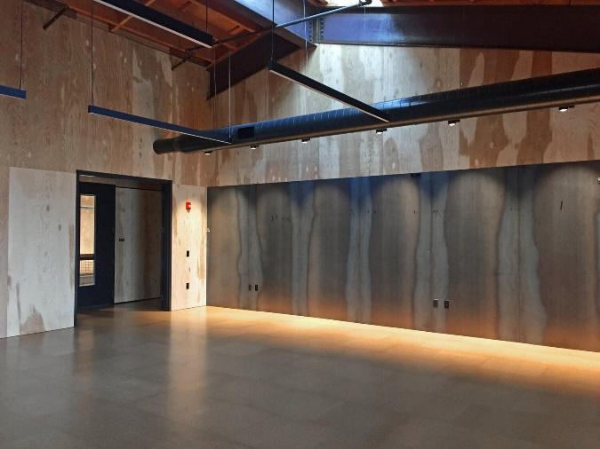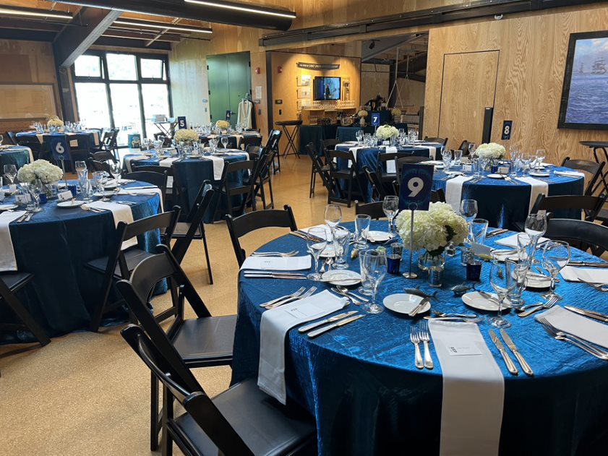
Capacity
The Sail Loft is 26’ x 44’ and can generally seat 80 for a sit-down dinner and up to 100 for a stand-up affair

Equipment Included in Rental
CWB has the following equipment onsite and available for renters, the use of this equipment is included in rental pricing.

Ten 60'' round tables | Generally seats 8; as many as 10
Ten 6' rectangular banquet tables | Generally seats 6; as many as 8
103 folding chairs | Color: Black

Floor Plan
WEC Second Level Floor Plan
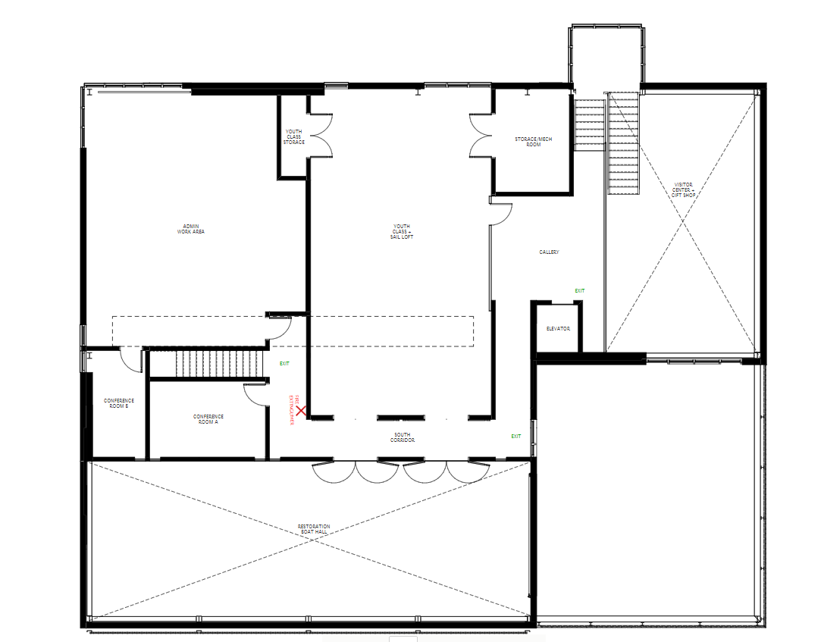

Boat House
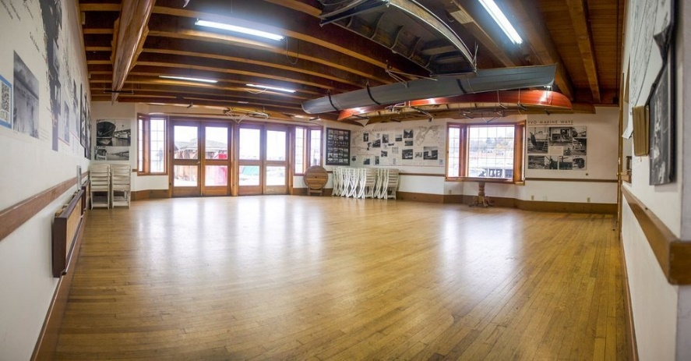
Located on the south end of Seattle’s Lake Union, our floating Boathouse is an official Seattle historical landmark. The boathouse and connected docks offer exceptional views of Lake Union and Seattle in every season. The event space is set amongst a notable collection of vessels in the marina, with the Space Needle and MOHAI to the west, and the full activity of the lake. It features hardwood floors, exposed beams highlighted with natural light from large windows. Through French doors, the North Deck offers a panorama of water views from a wood-plank dock, where guests can reconnect with the physical world and take in the scene of Seattle’s maritime heritage.
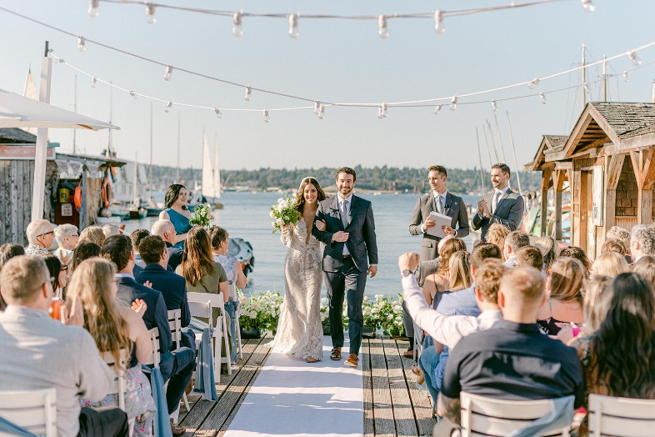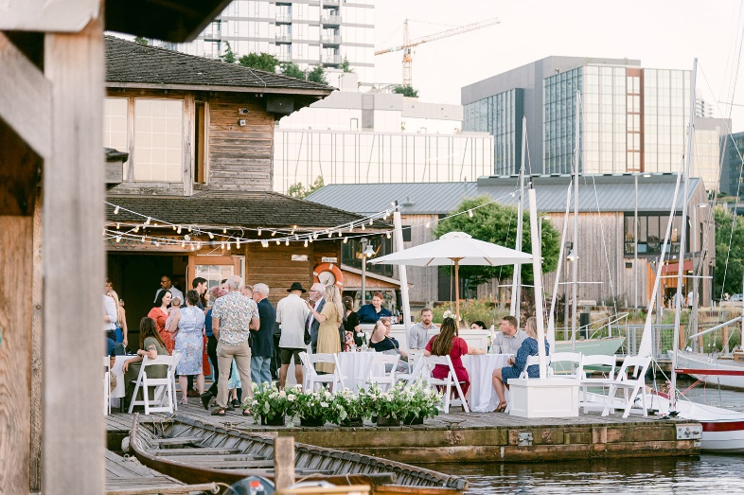

Capacity
The Boat House Gallery is located on the main floor (dock level) of the Boat House. It measures 28' x 28' and can generally seat 45 for a sit-down dinner and up to 60 for a stand-up affair. The level portions of the North Dock measure 39’ (east/west) by 32’ (north/south). It can add seating for 18 or standing room for 30.

Equipment Included in Rental
CWB has the following equipment onsite and available for renters, the use of this equipment is included in rental pricing.

Five 60'' round tables | Generally, seats 8; as many as 10
Eight 6' rectangular banquet tables | Generally, seats 6; as many as 8
30 White Folding Chairs
Projector & Pop-Up Screen | Epson Home Cinema 1060 (Full HD 1080p)  Screen Dimensions: 71.75” W x 48” H

Additional Equipment & Services
In addition to the tables and chairs, CWB offers add-ons to suit your needs.

Whiteboard |  | Includes markers and eraser | $25 Per day
Gas Grill |  | Includes propane | $150 Per day

Floor Plan
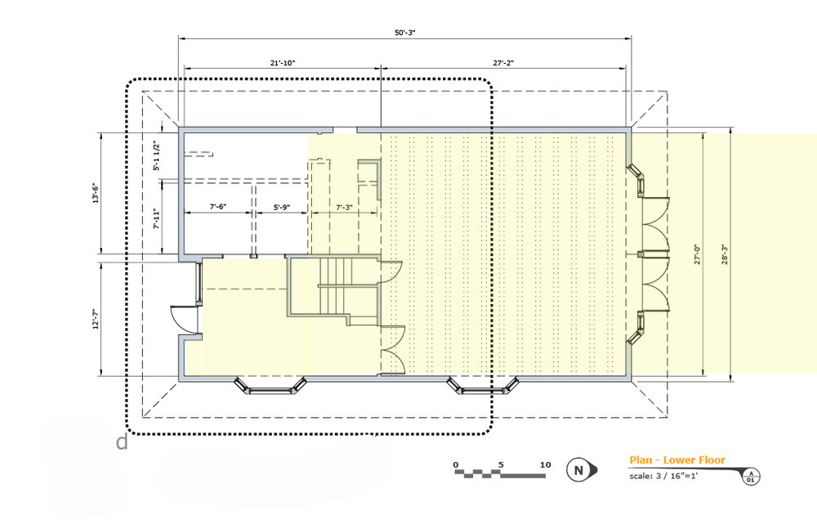

General Information

Livery Boat Use
Event guests may also rent CWB’s livery boats individually at regular rates. Guests must follow all Livery rules and guidelines when using CWB boats, and boats must be back to the dock at least 15 minutes before the Livery closes. Please see our website at www.cwb.org for current livery rates.
Please be aware that if a private event is scheduled during CWB operational hours, the public will still have access to boat rentals during the event. CWB does not stop public programming early for any reason.

Boat Moorage
Guests who wish to bring private boats down for the event may reserve linear moorage on the North Seawall in Lake Union Park, west of MOHAI. Reservation required and subject to availability. Contact CWB, 206-382-2628. Moorage rates for 2023 are $1.30 per linear foot of length over all (LOA).

Catering & Food Service
You may use the caterer of your choice, CWB does not provide any catering discounts, we do recommend Kaspars Catering. https://kasparsseattlecatering.com | https://kasparsseattlecatering.com/cwb-wagner-education-center/
Please Note: CWB is not a full-service rental facility and cannot deliver many services that large banquet halls may provide. Please read the rental agreement carefully and provide a copy to your caterer.

Deliveries & Pick-Up
Rental equipment, such as tableware, linens, and extra chairs, may be delivered the same day as the event for no fee. Delivered items may be stored on site the day of your event as long as they do not block any doors or interfere with CWB programs. If rental equipment is delivered early or picked up late, a $350 fee per day will be added to the rental bill.
Set-Up & Clean-Up

Set-up may not begin until the Renter or their representative has gone over the Clean-Up Checklist and Closing Procedures with CWB staff and signed the Rental Clean-Up Agreement. Renters may arrive up to 15 minutes before the appointed rental start time to review and sign the Rental Clean-Up Agreement.
The renting party is responsible for all set-up and clean-up, please remember to include enough time for set-up and clean-up in your reservation. The rental party accepts that CWB staff may still be prepping the space, and that exclusive use doesn’t begin until the designated event time. Activities such as visitors viewing the exhibits and volunteers using the kitchen may occur until that start time.
Clean-up includes renters' removal of trash, recycling and compost from the CWB premises. CWB does not have trash facilities to accommodate events, therefore ALL TRASH MUST BE DISPOSED OF OFFSITE.
Should renters fail to complete all tasks on the Rental Clean-Up Checklist to the satisfaction of CWB staff, they will be billed according to charges outlined (see Deposit Refund).

Concurrent Events in Lake Union Park
Renters should note that public events may occur at neighboring Lake Union Park or MOHAI at the same time as their rental at CWB. This may lead to increased noise, traffic and parking restrictions in the area.

General Availability
Before submitting a rental request, please review our calendar. Click here (or go to www.cwb.org and click “calendar” under the drop-down menu labeled “Events”) to ensure your desired date is available.
Seasonal Operating Hours:
Open daily Wednesday-Sunday
- Summer Hours (mid-March to late-September): 11am-7pm
- Fall Hours (late-September through early-November) 10am-6pm
- Winter Hours (early-November through mid-March) 10am-4pm
Please Note:
- CWB will have a Winter closure from December 11, 2023 - January 3, 2024. CWB does not book any events for facility rental during this time for any reason. Seasonal operating hours are also posted on our website here: http://cwb.org/locations/south-lake-union/.
- Our docks, excluding the North Deck area, remain open to the public until 8 pm. Stanchions are available for designating the North Deck as private.
- CWB’s docks and any CWB-owned boats not in use are available for non-exclusive event-related photography. Visiting Boats may be available with advance permission from owners.
- The Boatshop, offices, and other buildings and facilities are not available for rent. Guests are welcome to visit all areas as public visitors, but alcohol must remain within the event space.

Deposit & Payment Policies

Deposit Policy
A $500.00 security deposit is required to hold your reservation for all events. The deposit is refundable after the event, less any amounts deducted for cleaning, repair, or overtime use.
- The security deposit and 50% of the venue fee must be paid at the time of booking. The security deposit is not applied towards the balance owed.
- Full payment is due no later than 30 days prior to the event. If the rental is not paid at that time, the security deposit is forfeited, and the contract is terminated.
- Should an event run over the scheduled end-time on the contract, the renter will be charged the additional hour fee for every hour of overtime use.
- The renter will also be charged an additional hour fee for any set-up beginning before the scheduled access time on the contract.
- For reservations made within 30 days of the event, both security deposit and full payment are due at the time of CWB Rental Contract submission.

Deposit Refund
A refund of the Security Deposit, less any deductions, will be made within 30 days after the event. Charges can include, but are not limited to, the following:
Reason | Charge | Notes
Early Delivery/Late Pick-Up | $350.00 | Per day, Applied to early delivery/late pick-up.
Early Setup/Late Breakdown | $350.00 | Per hour, 1 hr. min. Applied if setup/breakdown is outside event hours.
Clean-Up Fee | $100.00 | Per hour, 1 hr. min. Applied if additional cleaning is needed from CWB.
Garbage/Recycle/Compost | $50.00 | Per bag, applied if left on premises.

Cancellations
In the event of cancellation, the Security Deposit is not refundable. If the rental is canceled more than 30 days prior to the event, you may reschedule to an alternate date within the same calendar year (pending availability) using the same Security Deposit. If the rental is canceled within 30 days of the event, security deposit and full balance are forfeited.

Potential Fees
Charges can include, but are not limited to the following:
Reason | Charge | Notes
Early Delivery/Late Pick-Up | $350.00 | Per day, Applied to early delivery/late pick-up.
Early Setup/Late Breakdown | $350.00 | Per hour, 1 hr. min. Applied if setup/breakdown is outside event hours.
Clean-Up Fee | $100.00 | Per hour, 1 hr. min. Applied if additional cleaning is needed from CWB.
Garbage/Recycle/Compost | $50.00 | Per bag, applied if left on premises.

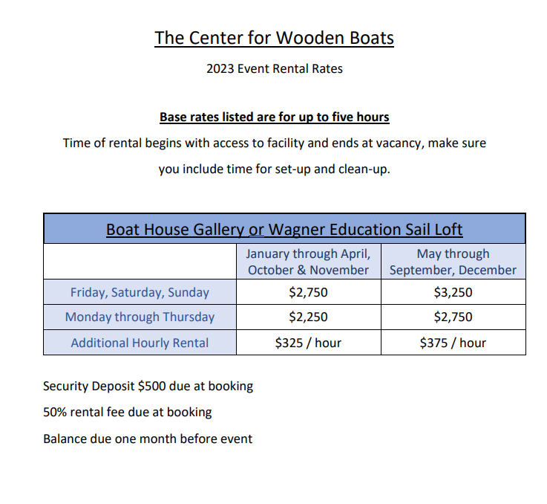

Availability & Pricing
Pricing and availability depend on the season, day of the week, and time of day.

Rental Timeline
Due Date | Action/Deliverable
Up to 18 months in advance | Initial reservation on our calendar
Two weeks after reservation | Signed Gallery Rental Contract, $500 Security Deposit and 50% of Venue Fee due
30 days before the event | Full Payment due
One week before the event | Estimated guest count due
Day of event | Rental Clean-Up Agreement walkthrough before setup
Within 30 days after the event | Refund of Security Deposit, less any charges

Discounts
Non-profit discounts: CWB does not consider requests to offer free facility rental for any reason but can provide a 20% discount to 501(c)(3) Non-Profit Organizations. The rental of this facility helps to support CWB’s mission: To provide a gathering place where maritime history comes alive through direct experience and our small craft heritage is enjoyed, preserved, and passed along to future generations. Rental rates are subject to the following discounts, one discount per event. Status must be current at the time of booking for discounts to apply.
- 501(c)(3) Non-Profit Organizations receive 20% off regular rates.
Member Discounts: CWB Contributing Member level and above receive a 10% discount on facility rental cost. Click here (Or visit www.cwb.org/membership) to learn more about becoming a member at CWB.

Facility Use

Use of Property

- The WEC Front Desk area and restrooms remain open to the public during operating hours. “Private Event” signs will be posted at all entrances during rentals.
- Seasonal operating hours are posted on our website here: http://cwb.org/locations/south-lake-union/.
- CWB provides rental space only, renters are responsible for hiring staff and crew to help run their event if needed. CWB staff and volunteers are not available to help set up, tear down, run the event, or clean up afterwards.
- Use of CWB buildings and spaces are limited to the designated area of rental and does not include other spaces such as (but not limited to) our front desk, closets, conference rooms, or offices.
- Any additional time needed for a renter's event must be included in the rental period such as: rehearsal dinners, photographs, set up, tear down, clen up, catering arrival, and other necessary operations to run your event.
- CWB will not move any boats in our collection docked at our marina for the convenience of facility renters for any reason.

Open Flame Use
Lanterns and open flames are not allowed. Candles may only be used on tabletops in the event areas. If using candles, they must be:
- Dripless
- Stationery
- Enclosed in non-flammable containers.
Prior approval required. Battery-operated tea lights are recommended. No candles are allowed in the Front Desk or restroom area.

Use of CWB’s Grill

Use of CWB’s grill is by prior agreement only. A fee will be charged (see Additional Equipment & Services). The grill must be set up on the North Deck, away from the building eaves, and at least six feet from the edge of any dock.

Parking
Parking at CWB and in the South Lake Union neighborhood is very limited and never guaranteed. CWB encourages guests and organizers to carpool and take alternate transportation whenever possible. Neighborhood parking options can be found here: http://seattleparking.spplus.com/seattle-south-lake-union-parking.html. However, we recommend that event guests use alternate modes of transit. For options, visit http://cwb.org/locations/south-lake-union/.
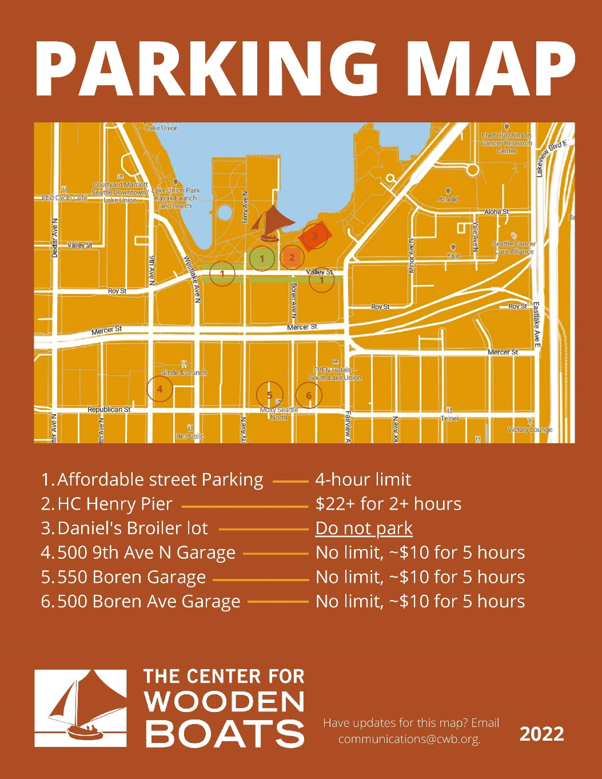

ADA Access & Parking
CWB’s docks and Boathouse are ADA-accessible. There are ADA parking spaces in the North Lot (see Loading In for access instructions) and in the Lake Union Park lot. These lots are shared, and spaces are non-reservable.

Loading In
- Access to the Gallery begins at the agreed-upon Event Start Time, specified in the Contract. No rental equipment or supplies may be loaded into the Gallery before that time (see Deliveries & Pick-Up).
- Renters may have access to the North Parking lot for loading and unloading. Before 5:00pm, use the callbox to request that the gate be opened (tell them that you are loading in for a CWB event). After 5:00pm, CWB staff will open the gate. CWB is unable to provide the gate code to renters.
- When offloading, do not park or stop vehicles in the fire lane road, especially at the top of CWB’s west ramp. Loading vehicles can temporarily (30 min or less) park in the spaces marked “Load/Unload” on the south side of the parking lot

Smoking
CWB is a smoke-free facility. Smoking of any substance is not allowed in any of CWB’s buildings, on any docks, in any boats, or in the neighboring Lake Union Park.

Alcohol
CWB allows only beer, wine and champagne to be served at events in the event venues. No hard liquor is allowed. All alcohol must remain within the rental area of the Boathouse and North Deck or the WEC. No alcohol is allowed in Lake Union Park.
If your party plans to serve alcohol, a Banquet Permit from the Washington State Liquor Control Board is required (http://liq.wa.gov/licensing/banquet-permits).
Alcohol and Boats Policy
- Alcohol is not allowed when boarding or operating our boats.
- You may bring alcohol aboard chartered cruises that are operated by our licensed captain.
- Livery boats will not be rented to customers who show signs of intoxication or alcohol/drug use.

Decorations
CWB’s event venues double as classrooms and exhibit galleries. Please respect the exhibits, artifacts, and ecosystem by abiding by these rules:
- No tape, nails or staples may be used on walls or rafters. Decorations may be hung from existing hooks and nails, but not from exhibit boats displayed on gallery ceiling or their supports. Blue painter’s tape may be used on some surfaces with prior approval.
- Candles are permitted only with prior approval (see Open Flame). An example of an approved open flame is lighting unity candles as part of a wedding ceremony.
- No rice, confetti, birdseed, potpourri, glitter or any substance of that nature may be used.
- Flower petals may be used for decorating purposes on tables only and must be cleaned up entirely.
- Supplemental lighting may be used both inside and outside in the form of string lights and/or centerpieces. Exterior lighting can be hung from existing nails and hooks on the Boathouse eaves, and on freestanding posts (provided by renter) along the edge of the North Deck.

Canopies and Furniture
Any canopies or furniture used on CWB property must be free-standing. They may be supported by weights or tied down to existing bull rails for additional support. Nails, screws, staples and similar means of fastening are not allowed. See Damage or Defacement of Property.

Damage or Defacement of Property
By renting the venue, it is understood and agreed that the renter will take responsible precautions to prevent persons admitted to the premises from damaging or defacing the premises. In the event that the premises are damaged or defaced by the act, default, or negligence of the renter, or any employee or guest of the renter, the renter shall pay CWB the amount necessary to restore damaged portion of the premises to its original condition. Please encourage guests to avoid wearing high heels, as they damage the hardwood floors and are extremely dangerous on the docks.

Noise Levels
CWB allows amplified sound systems and live bands inside its buildings – outside approved on case-by-case basis to be considerate of our neighbors. Events must abide by Seattle City Noise Code (http://www.seattle.gov/dpd/codesrules/codes/noise/).
Renters may be allowed to include live music, DJs, or amplified music at the event with prior approval.
Please note: CWB does not offer any sound system equipment for event rental use. See the list below for sound equipment rental recommendations:
- DA Sound
- Seattle Event Rentals
- Play Event Rentals
- Meeting Tomorrow
- Eventective

Violation of Rules
By renting the venue, it is understood and agreed that, should your group fail to adhere to all rules and policies, and conform to the proper use of the building, The Center for Wooden Boats may, at its discretion, terminate this agreement and require the renting parties to vacate the building (during the event if necessary), forfeiting all fees and monies.

Indemnification
By renting the venue, it is understood and agreed that the renter shall indemnify and hold CWB harmless from all losses, claims, actions or damages suffered by any person or persons by reason of, or resulting from, any act or omission.

Notes

